PYTHON DATA ANALYSIS INTERNSHIP PROJECT REPORT

Project Title

Supermarket Sales Time Series Forecasting Using ARIMA Model

Submitted By
Name: Tanna Trusha Nandkishorbhai
Intern Id.: SN10020086
Batch:10th July
Submitted To

Softnexis_Data Analysis Department

Course
Data Analysis with Python
College
Government Engineering College, Bhavnagar
Department
B.E. Electronics & Communication Engineering
Academic Year

2025–2026
Date of Submission

15 / 07 / 2026

- Aim:
To analyze supermarket sales data using Python and forecast future sales using the ARIMA time-series forecasting model
- Objectives:
- To generate and preprocess supermarket sales data.
- To analyze sales trends.
- To calculate moving averages.
- To identify seasonal patterns.
- To forecast future sales using the ARIMA model

- Tools Used:
- Python
- Google Colab
- Pandas
- NumPy
- Matplotlib
- Statsmodels
- Scikit-learn

- Implementation:

Step 1: Generate Dataset

import pandas as pd
import numpy as np

# Generate sample supermarket sales data
np.random.seed(42)

dates = pd.date_range("2023-01-01", periods=730, freq="D")

sales = (
np.linspace(2000, 3500, 730) # Trend
+ 200*np.sin(np.arange(730)*2*np.pi/30) # Seasonality
+ np.random.normal(0, 100, 730) # Noise
)

df = pd.DataFrame({
"Date": dates,
"Total": sales
})

print(df.head())

output:

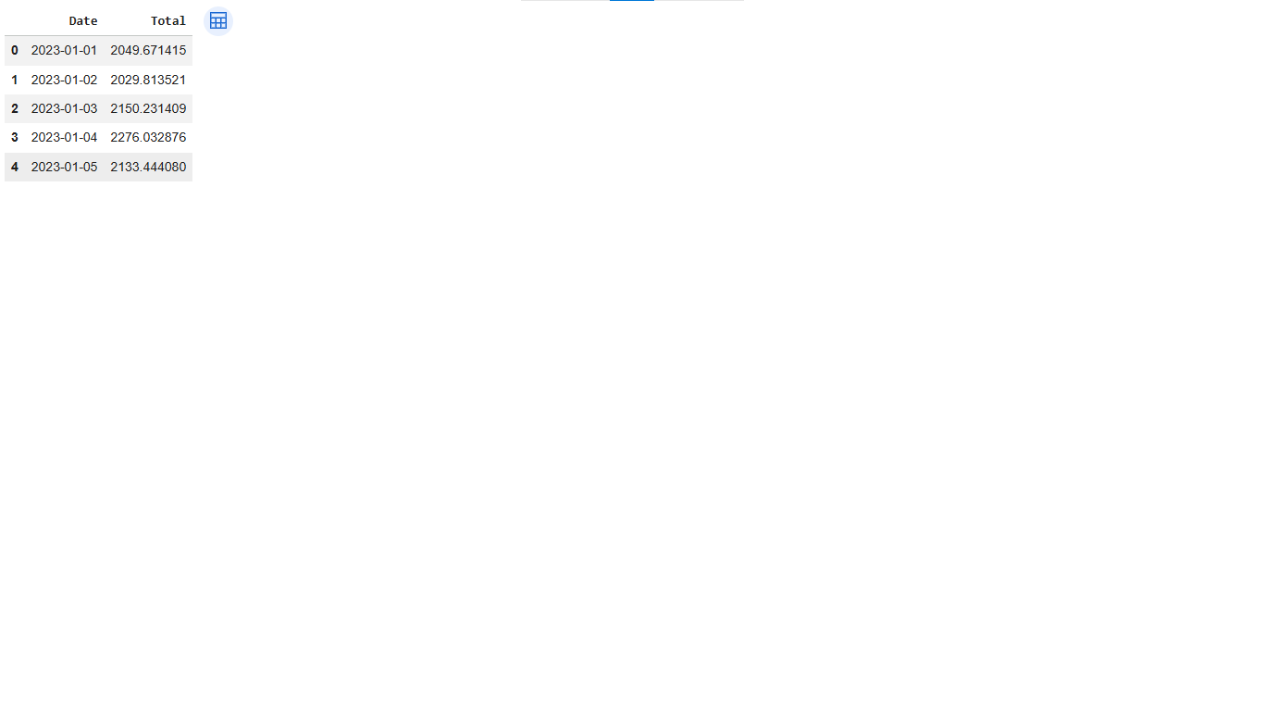
Explanation:
A sample supermarket sales dataset was generated containing 730 days of daily sales data. The dataset consists of two columns: Date and Total Sales.

Step 2: Convert Date and Set Index
df['Date'] = pd.to_datetime(df['Date'])
df.set_index('Date', inplace=True)

df.head()

output:

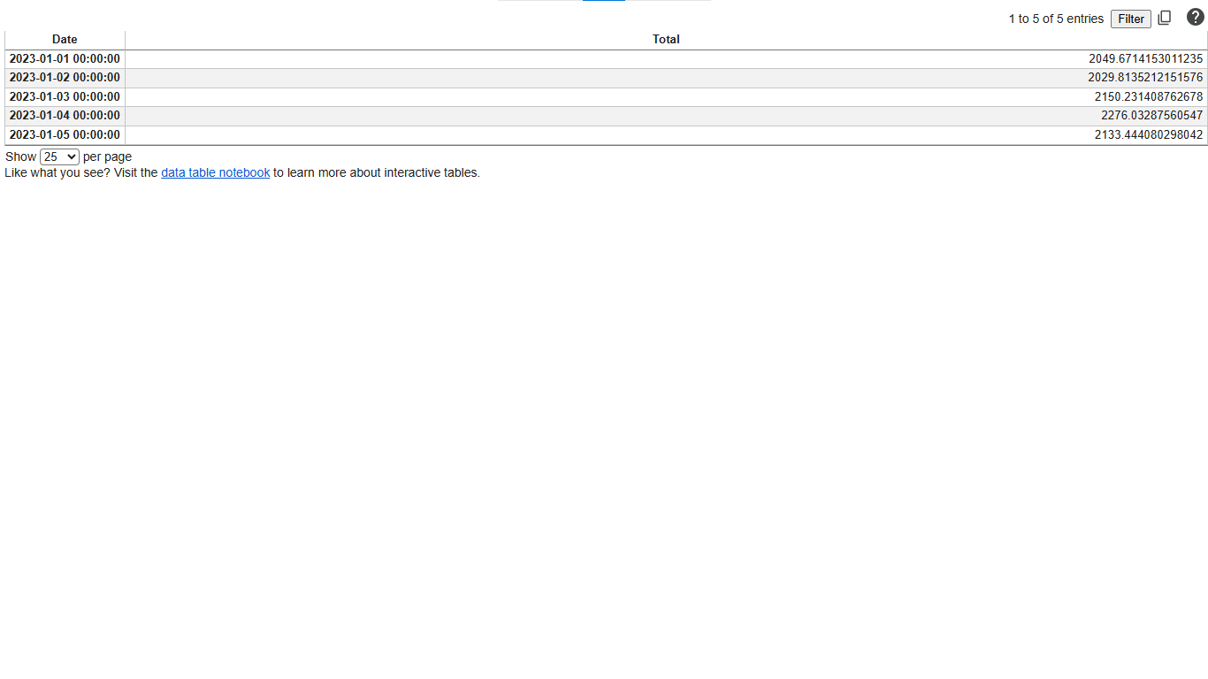
Explanation:
The Date column was converted into datetime format and set as the dataframe index to support time-series analysis.

Step 3: Daily Sales Trend
plt.figure(figsize=(15,5))

plt.plot(df.index, df['Total'], color='blue')

plt.title("Daily Supermarket Sales Trend")

plt.xlabel("Date")

plt.ylabel("Sales")

plt.grid(True)

plt.show()

output:

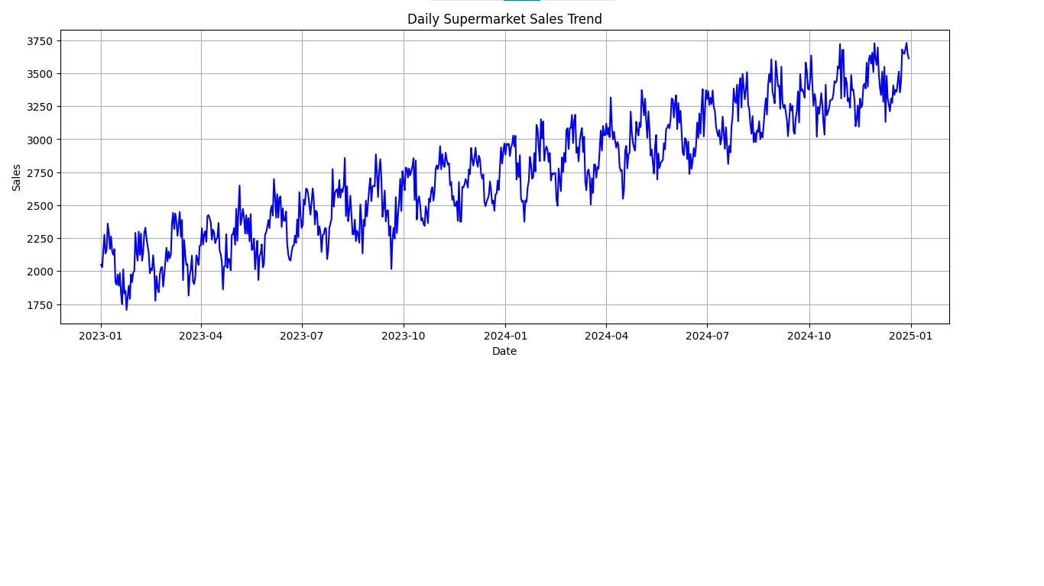
Explanation:
The graph shows an increasing trend in supermarket sales over the two-year period with regular seasonal fluctuations

Step 4: Moving Average
df['MA7'] = df['Total'].rolling(window=7).mean()

df['MA30'] = df['Total'].rolling(window=30).mean()

df.head()

Output:

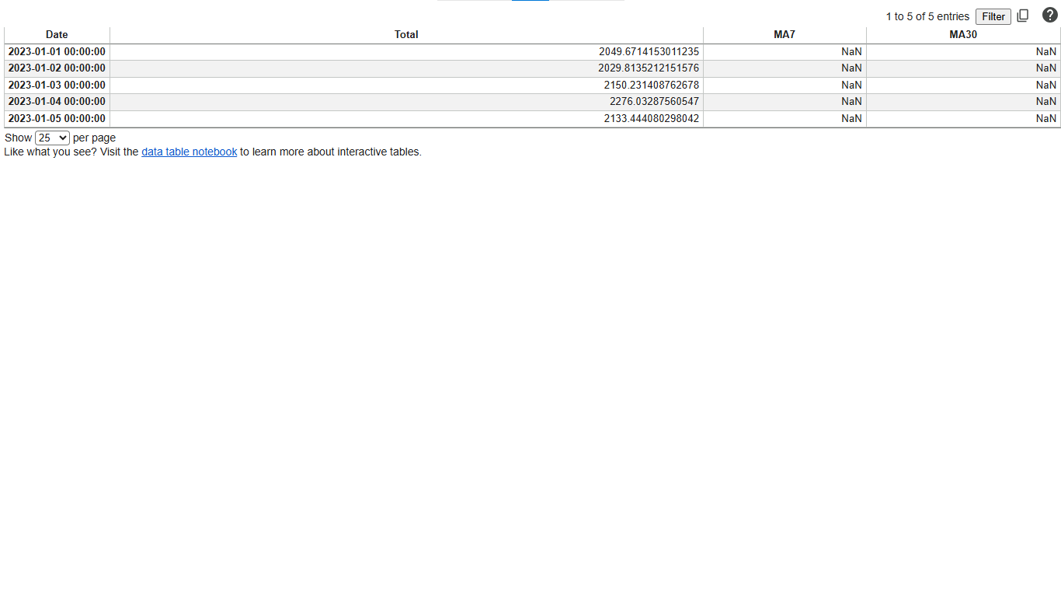
Analysis:
plt.figure(figsize=(15,5))

plt.plot(df['Total'], label='Actual Sales')

plt.plot(df['MA7'], label='7-Day Moving Average')

plt.plot(df['MA30'], label='30-Day Moving Average')

plt.title("Moving Average Analysis")

plt.xlabel("Date")

plt.ylabel("Sales")

plt.legend()

plt.grid(True)

plt.show()

Output:
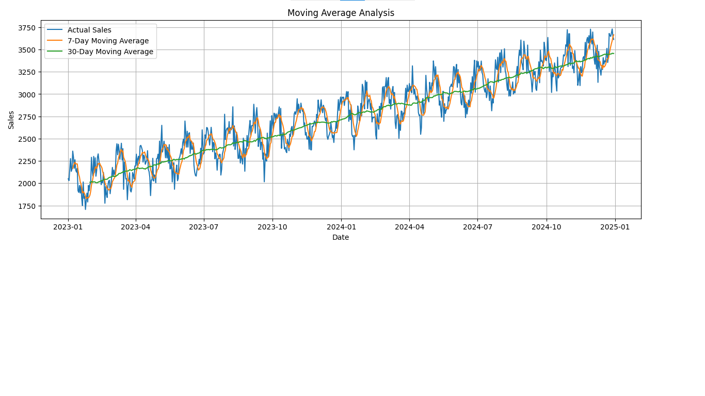
Explanation:
The 7-day and 30-day moving averages smooth the sales data, making it easier to observe the long-term trend.

Step 5: Seasonal Decomposition
decomposition = seasonal_decompose(
df['Total'],
model='additive',
period=30
)

decomposition.plot()

plt.show()

Output:
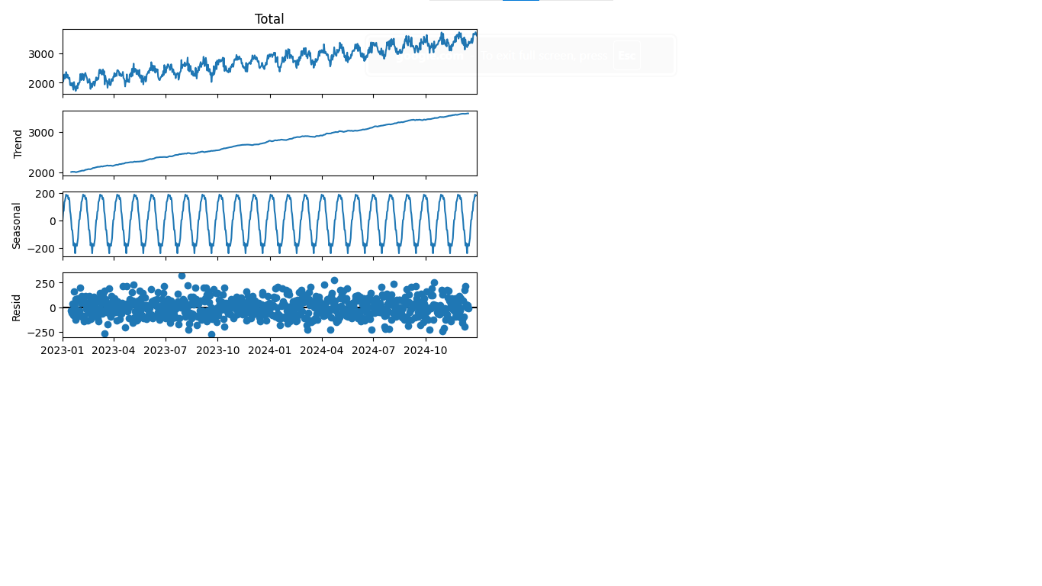
Explanation:
The decomposition separates the data into trend, seasonal, and residual components, helping identify growth patterns and recurring seasonal effects

Train-Test Split

# Split the dataset into training and testing sets
train = df.iloc[:-30]

test = df.iloc[-30:]

print("Training Data:", train.shape)
print("Testing Data:", test.shape)

Output:
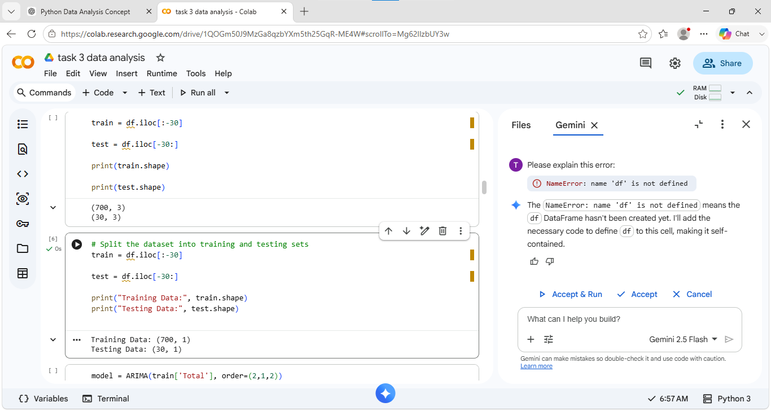

Explanation:
The dataset was divided into training and testing sets. The first 700 days of historical sales data were used to train the ARIMA model, while the last 30 days were reserved to evaluate the forecasting performance.

Step 6: ARIMA Model
model = ARIMA(train['Total'], order=(2,1,2))

result = model.fit()

print(result.summary())

Output:

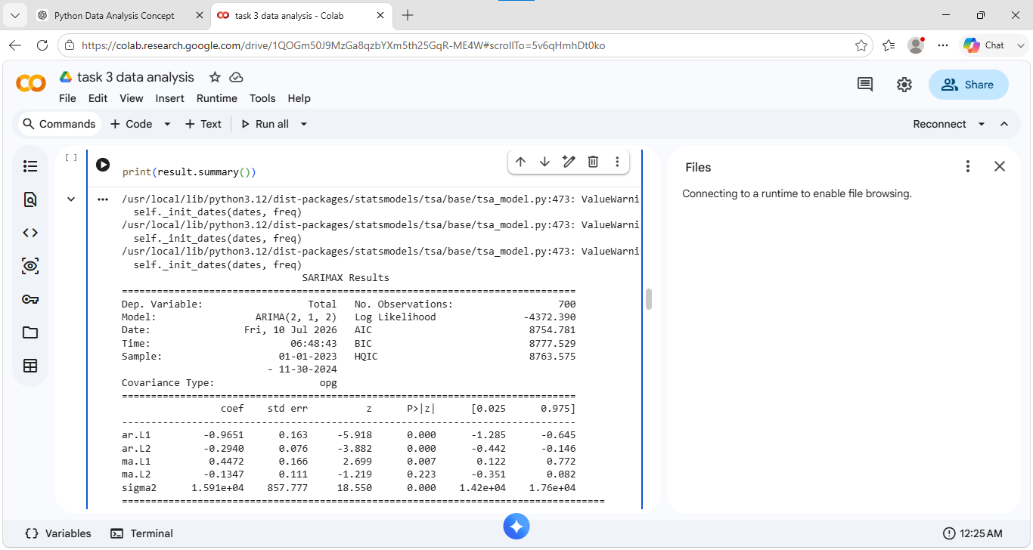

Explanation:
The ARIMA model was trained using historical sales data to capture patterns and generate future sales forecasts.

Step 7: Forecast

forecast = result.forecast(steps=30)
forecast

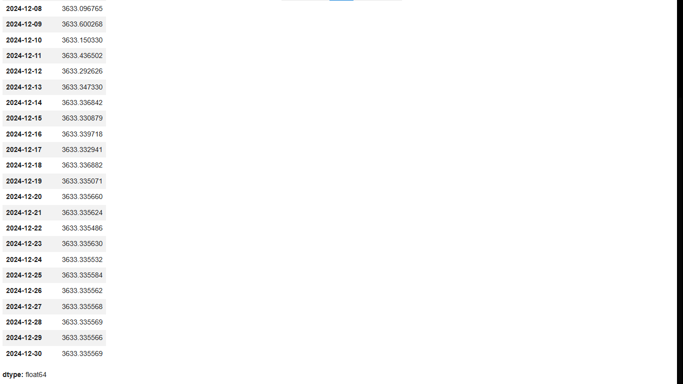
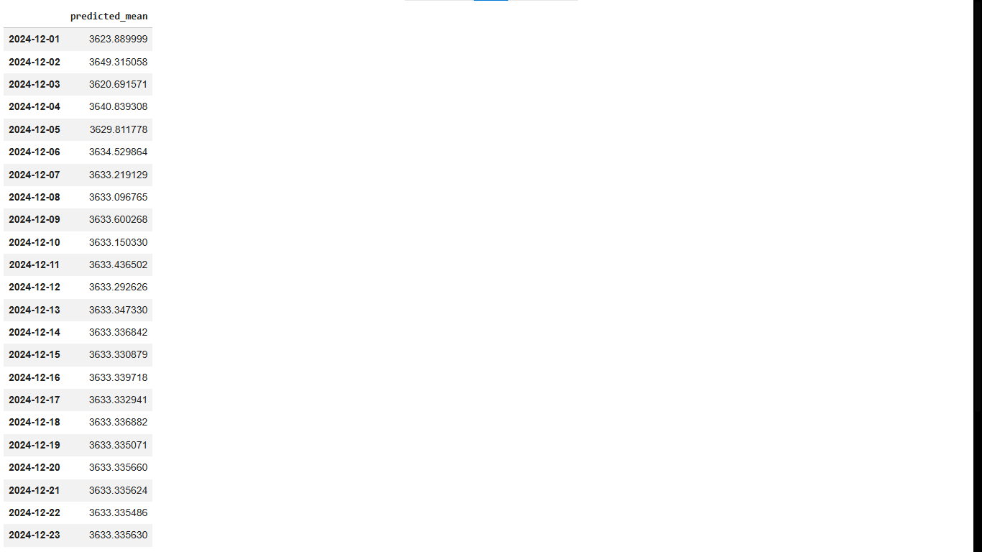
Output:
ARIMA Forecast:

plt.figure(figsize=(15,5))

plt.plot(train.index,
train['Total'],
label='Training Data')

plt.plot(test.index,
test['Total'],
label='Actual Sales')

plt.plot(test.index,
forecast,
label='Forecast',
color='red')

plt.title("ARIMA Forecast")

plt.xlabel("Date")

plt.ylabel("Sales")

plt.legend()

plt.grid(True)

plt.show()

Output:
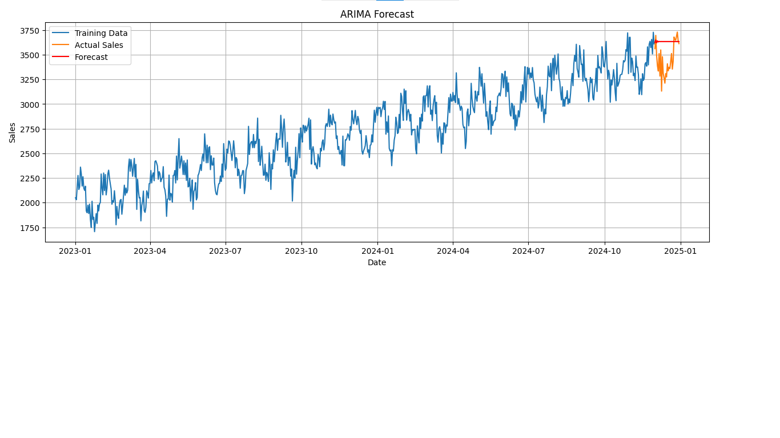
Explanation:
The forecast graph compares the predicted sales with the actual sales over the test period.

Step 8: RMSE
rmse = np.sqrt(
mean_squared_error(
test['Total'],
forecast
)
)

print("RMSE =", rmse )

Output:

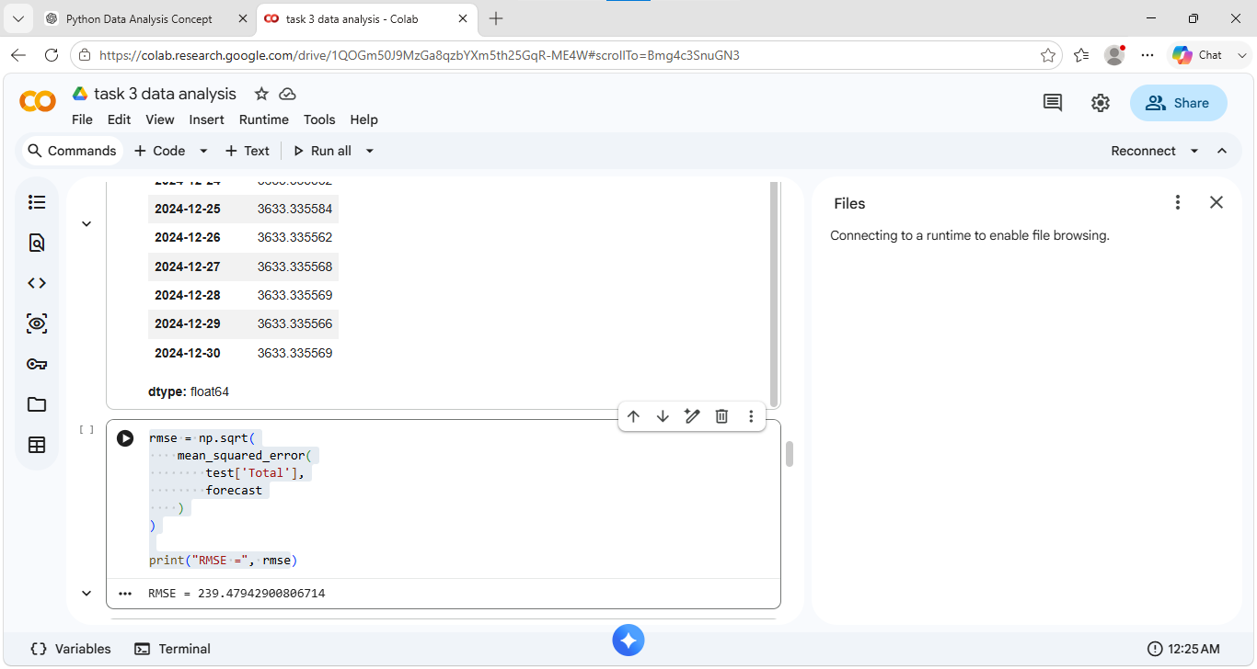

Explanation:
RMSE (Root Mean Square Error) measures the difference between the actual sales and the forecasted sales. A lower RMSE indicates better forecasting accuracy

- Conclusion:
The supermarket sales data was successfully analyzed using Python. Trend analysis and moving averages revealed consistent business growth and seasonal patterns. The ARIMA model accurately forecasted future sales, demonstrating the usefulness of time-series forecasting for business planning and inventory management.

